AIM OF THE EXPERIMENT:
To find the shear of the soil by Undrained Triaxial Test.
APPARATUS REQUIRED:
- Special:
- A constant rate of strain compression machine of which the following is a brief description of one is in common use.
- A loading frame in which the load is applied by yoke acting through an elastic dynamometer, more commonly called a proving ring which used to measure the load. The frame is operated at a constant rate by a geared screw jack. It is preferable for the machine to be motor driven, by a small electric motor.
- A hydraulic pressure apparatus including an air compressor and water reservoir in which air under pressure acting on the water raises it to the required pressure, together with the necessary control valves and pressure dials.
- A triaxial cell to take 3.8 cm dia and 7.6 cm long samples, in which the sample can be subjected to an all round hydrostatic pressure, together with a vertical compression load acting through a piston. The vertical load from the piston acts on a pressure cap. The cell is usually designed with a non-ferrous metal top and base connected by tension rods and with walls formed of Perspex.
- General:
- 3.8 cm (1.5 inch) internal diameter 12.5 cm (5 inches) long sample tubes.
- Rubber ring.
- An open ended cylindrical section former, 3.8 cm inside dia, fitted with a small rubber tube in its side.
- Stop clock.
- Moisture content test apparatus.
- A balance of 250 gm capacity and accurate to 0.01 gm.
THEORY:
Triaxial test is more reliable because we can measure both drained and untrained shear strength.
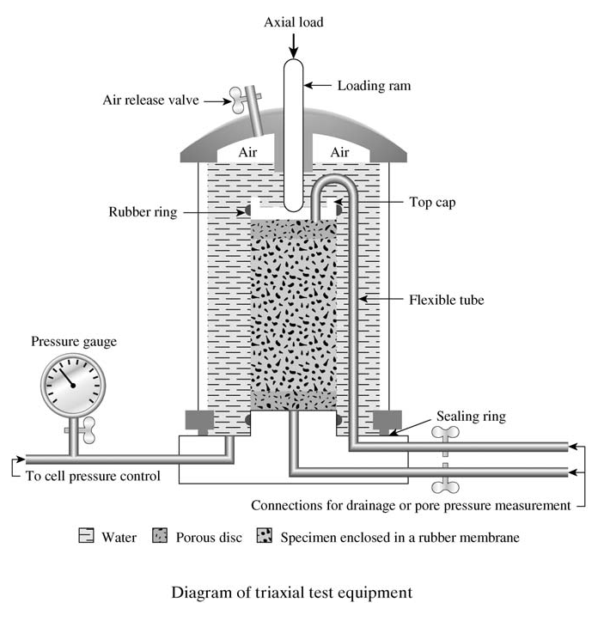
Generally 1.4” diameter (3” tall) or 2.8” diameter (6” tall) specimen is used. Specimen is encased by a thin rubber membrane and set into a plastic cylindrical chamber. Cell pressure is applied in the chamber (which represents σ3’) by pressurizing the cell fluid (generally water).
Vertical stress is increased by loading the specimen (by raising the platen in strain controlled test and by adding loads directly in stress controlled test, but strain controlled test is more common) until shear failure occurs. Total vertical stress, which is σ1’ is equal to the sum of σ3’ and deviator stress (σd). Measurement of σd, axial deformation, pore pressure, and sample volume change are recorded.
Depending on the nature of loading and drainage condition, triaxial tests are conducted in three different ways.
- UU Triaxial test
- CU Triaxial test
- CD Triaxial test
APPLICATION:
UU triaxial test gives shear strength of soil at different confining stresses. Shear strength is important in all types of geotechnical designs and analyses.
PROCEDURE:
- The sample is placed in the compression machine and a pressure plate is placed on the top. Care must be taken to prevent any part of the machine or cell from jogging the sample while it is being setup, for example, by knocking against this bottom of the loading piston. The probable strength of the sample is estimated and a suitable proving ring selected and fitted to the machine.
- The cell must be properly set up and uniformly clamped down to prevent leakage of pressure during the test, making sure first that the sample is properly sealed with its end caps and rings (rubber) in position and that the sealing rings for the cell are also correctly placed.
- When the sample is setup water is admitted and the cell is fitted under water escapes from the beed valve, at the top, which is closed. If the sample is to be tested at zero lateral pressure water is not required.
- The air pressure in the reservoir is then increased to raise the hydrostatic pressure in the required amount. The pressure gauge must be watched during the test and any necessary adjustments must be made to keep the pressure constant.
- The handle wheel of the screw jack is rotated until the underside of the hemispherical seating of the proving ring, through which the loading is applied, just touches the cell piston.
- The piston is then removed down by handle until it is just in touch with the pressure plate on the top of the sample, and the proving ring seating is again brought into contact for the begging of the test.
PRECAUTIONS:
OBSERVATION AND CALCULATION TABLE:
The machine is set in motion (or if hand operated the hand wheel is turned at a constant rate) to give a rate of strain 2% per minute. The strain dial gauge reading is then taken and the corresponding proving ring reading is taken the corresponding proving ring chart. The load applied is known. The experiment is stopped at the strain dial gauge reading for 15% length of the sample or 15% strain.
- Size of specimen :
- Length :
- Proving ring constant :
- Diameter : 3.81 cm
- Initial area L:
- Initial Volume :
- Strain dial least count (const) :
Sample No. | Wet bulk density gm/cc |  | Cell pressure kg/cm² |  | Compressive stress at failure |  | Strain at failure | Moisture content |  | Shear strength (kg/cm²) |  | Angle of shearing resistance
1
2
3
Cell pressure kg/cm² |  | Strain dial |  | Proving ring reading |  | Load on sample kg |  |  | Corrected area cm² |  | Deviator stress
0.5 |  | 0
 |  | 50
 |  | 100
 |  | 150
 |  | 200
 |  | 250
 |  | 300
 |  | 350
 |  | 400
 |  | 450
0.5 |  | 0
 |  | 50
 |  | 100
 |  | 150
 |  | 200
 |  | 250
 |  | 300
 |  | 350
 |  | 400
 |  | 450
0.5 |  | 0
 |  | 50
 |  | 100
 |  | 150
 |  | 200
 |  | 250
 |  | 300
 |  | 350
 |  | 400
 |  | 450

GENERAL REMARKS:
- It is assumed that the volume of the sample remains constant and that the area of the sample increases uniformly as the length decreases. The calculation of the stress is based on this new area at failure, by direct calculation, using the proving ring constant and the new area of the sample. By constructing a chart relating strains readings, from the proving ring, directly to the corresponding stress.
- The strain and corresponding stress is plotted with stress abscissa and curve is drawn. The maximum compressive stress at failure and the corresponding strain and cell pressure are found out.
- The stress results of the series of triaxial tests at increasing cell pressure are plotted on a mohr stress diagram. In this diagram a semicircle is plotted with normal stress as abscissa shear stress as ordinate.
- The condition of the failure of the sample is generally approximated to by a straight line drawn as a tangent to the circles, the equation of which is t = C + a tan f. The value of cohesion ‘C’ is read of the shear stress axis, where it is cut by the tangent to the mohr circles, and the angle of shearing resistance (f) is angle between the tangent and a line parallel to the shear stress.
QUESTIONNAIRE:
- Why triaxial testing is considered. As test-like conditions in the most natural?
- How CU test is different from a test CD.
- Why has the UU test φ = 0, or in other words, when adding Confining Pressure. Under the soil to the same explanation.

- In a triaxial compression test on a soil the relation between σ1, σ2 & σ3
- σ1= σ2 + σ3
- σ2= σ1 - σ3
- σ2 = σ3
- none
- In triaxial compression test on a soil specimen the intermediate principle stress is equal to
- Major principle stress
- Minor principle stress
- Both a & b
- None
- In triaxial compression test the application of additional axial stress on the soil specimen produces shear stress on
- Horizontal plane only
- Vertical plane only
- Both a & b
- All planes except a and b
- When drainage is allowed during the first stage only and not during the second stage the test is known as
- CD test
- CU test
- UD test
- UU test
- Triaxial shear test is used for
- Cohesive soils
- Cohessionless soils
- Clays
- All soils
- Plot of a undrained triaxial test on saturated sand is
- Parallel to x axis
- Parallel to y axis
- Inclined at 45⁰
- None
- Deviator stress is equal to ______ for clays is
- σ1= σ2 + σ3
- σ2= σ1 - σ3
- σ2 = σ3
- none
- The phenomenon of increase in volume of the soil during shearing is called
- Dilation
- Compaction
- Consolidation
- none

PART – 2
ANIMATION STEPS
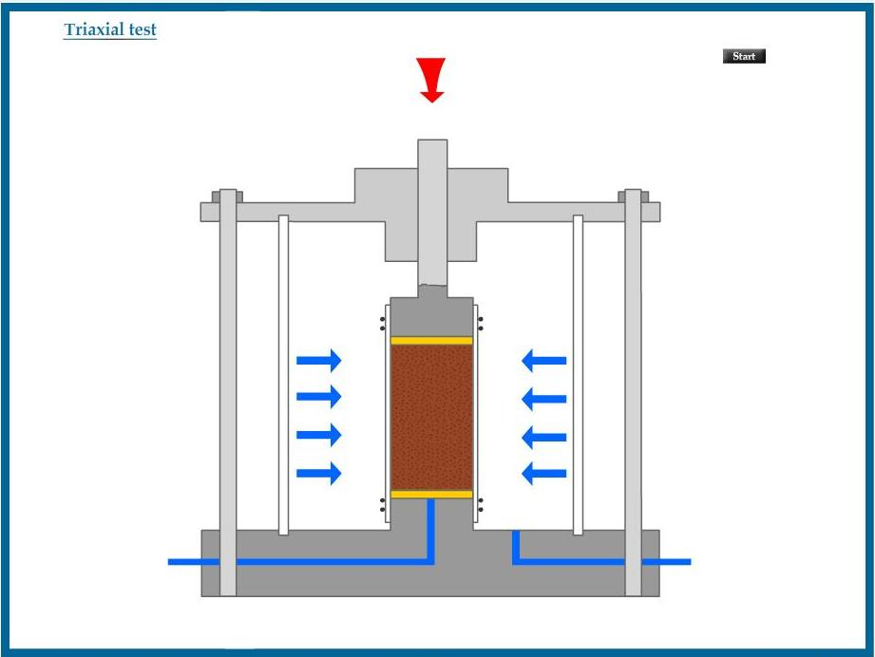

PART – 3
VIRTUAL LAB FRAME

